**Lab 4 - More on conditions, Strings and for-Loops**

**(Part II)**

**Note:** This part of Lab 4 is for you to complete using Notepad++ and Anaconda Prompt.

**Q7: Count Words [ ** ]**

In this question we’ll count the number of “a” and “an” in a piece of text.

**Note:** For this question, you are NOT allowed to use the count() method of string.

Inside a file called count_words.py, define the following functions.

1. Write a function called count_a that takes in a piece of text (as a string) and returns the number of times the word “a” occurs in the text. You do not need to handle uppercase “A”. You can assume that each time the word “a” occurs, both its previous character and its next character are a space.

For example, count_a("I have a room with a window, a desk and a chair.") should return 4.

1. Write a function called count_an that takes in a piece of text (as a string) and returns the number of times the word “an” occurs in the text. You do not need to handle uppercase “An”. You can assume that each time the word “an” occurs, its previous character and its next character are both a space.

For example, count_an("Every day I have an egg, an apple and a banana for breakfast.") should return 2.

Use the provided count_words_test.py file to test your code. You should not modify count_words_test.py.

**Q8: Fibonacci Numbers [ *** ]**

Refer to the following link to understand Fibonacci numbers:

<https://en.wikipedia.org/wiki/Fibonacci_number>

Essentially, it is a sequence of numbers where each number is equal to the sum of its previous two numbers in the sequence.

Inside a file called fibonacci.py, write a function called display_fibonacci(). This function takes in an integer n (greater or equal to 3). It **prints out** the first n Fibonacci numbers, starting from 1. The function doesn’t return anything.

For example:

display_fibonacci(3) prints out the following output: 1 1 2

display_fibonacci(5) prints out the following output: 1 1 2 3 5

display_fibonacci(10) prints out the following output: 1 1 2 3 5 8 13 21 34 55

Use the provided file fibonacci_test.py to test your implemented function. You should not modify fibonacci_test.py.

Note: In Week 3’s extra in-class exercises we had the same question. However, for this Lab 4, you should use for-loops to solve the problem (and recursive functions are not needed).

**Q9: Playing with Strings [ *** ]**

**Part I**

Write a program that prompts the user for a string as a message. The program displays a triangle that gradually reveals the whole message, as shown below.

Suppose the message is “Hello!”. The program displays the following output:

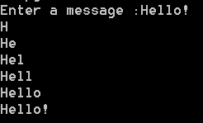

Suppose the message is “Python”. The program displays the following output:

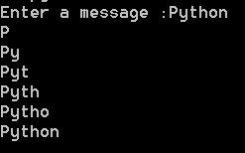

**Part II**

Write a similar program that displays the triangle upside down, as shown below.

Suppose the message is “Hello!”. The program displays the following output:

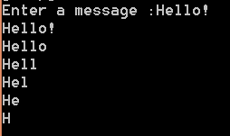

Suppose the message is “Python”. The program displays the following output:

